Week 1
Interface chosen
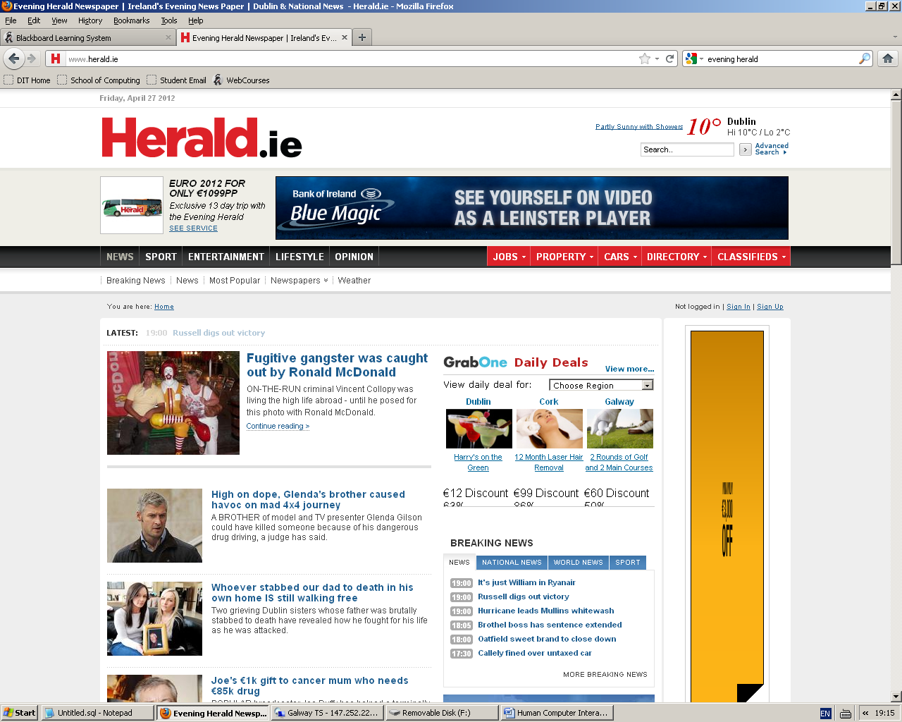

This is the front page of the interface that we have chosen for our project. We felt we could improve on this interface.

Methods of Research:
Our methods of research for this interface were the internet and we also gained an interview with an employee of the newspaper that owns the webpage, he gave us a insight on how the website is run and background information on why the website isn’t as good as rival newspapers.

Life Cycle:
The Star Life Cycle is the one chosen for this website. The Star Life Cycle Design Approach is centered on evaluation and doesn’t specify order to the activities surrounding this evaluation. It has a high level of iteration throughout the design process. The star life cycle approach has the great benefit of being able to utilise user evaluation throughout the whole design process, adapting to the needs of the users as they are discovered and as they (invariably) change. This is ideal for websites as they must be user friendly and constant feedback is paramount to a websites success.
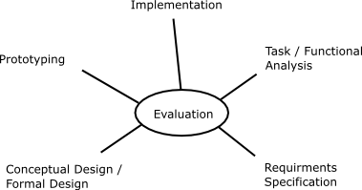

Use Case Diagram:
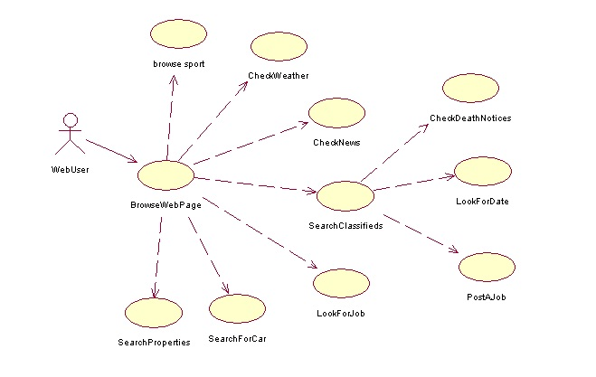
Above is a simple use case of our low fidelity prototype. This will be used in the construction of our medium fidelity prototype and then in the more comprehensive medium fidelity prototype.
USER GROUPS:
The user groups that this website is focused on would be late 20s to early 50's users with some knowledge of how to use websites.

Interaction Models 7 stages of action:
Forming the goal: | Browsing the website
Forming the intention: | To enter the correct key sequence to get to desired page
Specifying the action: | To move the body to reach the appropriate buttons to browse the web
Executing the action: | Pressing the keys and getting to site
Perceiving the state of the world: | Browsing the website and seeing if it works
Interpreting the state of the world: | The link brings you to another page
Evaluating the outcome: | Website did not perform as expected
This interface has a gulf of evaluation as the webpage linked to an outside webpage.
Low Fidelity Prototype:
Below is an image of a low fidelity prototype which was drawn on a sheet of paper this will be the basis for further prototypes. With our low fidelity prototype our aim was to get the layout and build on this layout. We would also implement some of the cognitive processes like grouping, good visibility of the main pages and easily accessible interface.

